**Assignment 4.2**

1. Write a program to create barplots for all the categorical columns in mtcars.

Answer:

> barplot <- ggplot(mtcars,aes(Type))+

+ geom_bar(width = 0.5,fill="royalblue4",color="red")+

+ ggtitle("gear Count by Category")

> barplot

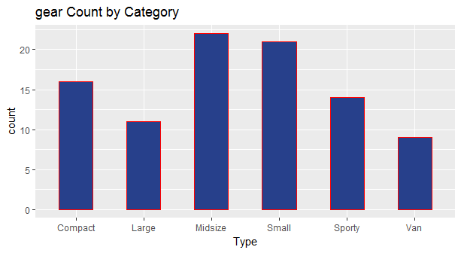

2. Create a scatterplot matrix by gear types in mtcars dataset.

> scatterplot <- ggplot(mtcars,aes(gear,hp))+

+ geom_point(color="dodgerblue",size=5)+ggtitle("Basic Scatterplot")+

+ theme(plot.title= element_text(size = 12, face = "bold"))

> scatterplot

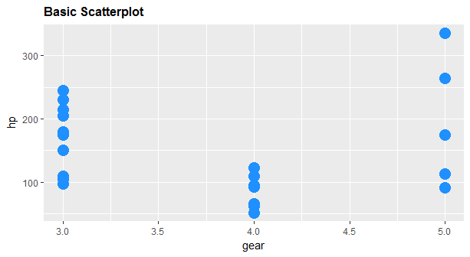

3. Write a program to create a plot density by class variable.